Bioinformatics Application Note:

Genome Convergence Pipeline

Abstract
Summary. Genome Convergence Pipeline consists of a Java API and an executable binary jarfile with graphical user interface (GUI) for the high-throughput analysis of phylogenomic datasets to detect convergent molecular evolution.

Motivation. Although convergent phenotypes are readily observed in nature evidence that evolution can produce convergent signals in genetic sequences have only recently emerged. The Genome Convergence Pipeline facilitates these analyses.

Results. The application has been successfully implemented on a variety of infrastructures.

Availability and implementation. The API is implemented in native Java code, available online at []. The executable binary can be downloaded at []

Contact. joe@kitson-consulting.co.uk

Introduction
Although convergent phenotypes are readily observed in nature evidence that evolution can produce convergent signals in genetic sequences have only recently emerged. The Genome Convergence Pipeline facilitates these analyses.

Convergent evolution is non-neutral mode of DNA evolution very recently discovered in living organisms and a subject of extremely vigorous debate in the literature. This pipeline is in use by our lab on customised computer configurations, but its wider uses are of great interest to the field, as evidenced by continuous and growing numbers of requests to use our software. Our software leverages open-source and academic freeware algorithms (as well as our own), and our advanced know-how in phylogenetic analysis of genomic data, to detect subtle but important signals of convergent molecular evolution.

Detection of convergent molecular evolution is an emerging field with relevance to primary research, biomedical and agribusiness applications. Several methodological frameworks exist, one pioneered by us. As yet no user-friendly pipeline or software is readily available; furthermore these techniques require expertise handling very large phylogenomic datasets that is beyond many researchers in public and private spheres. Critically, the availability of DNA sequence data driving demand for these analyses continues to expand at an exponential rate: but RCUK, academics, and industry have all identified DNA sequence analysis capacity and expertise as a very significant bottleneck in exploiting this mass of data (e.g. Funari & Canosa (2014): Science / AAAS Webinar: http://bit.ly/1tDx3Mi; RCUK Shortage Occupation Announcement: http://bit.ly/15Otx6G).

Our pipeline meets this need, enabling users without expertise in phylogenomic analyses of very large genomic datasets to rapidly and robustly perform highly parallel computation. This will lower the bar to entry for these analyses. Furthermore, by providing the first enterprise-grade implementation of these techniques we will capture a significant share of this market, and drive further growth in this area.

Features and implementation
Genome Convergence Pipeline consists of a Java API and an executable binary jarfile with graphical user interface (GUI) for the high-throughput analysis of phylogenomic datasets to detect convergent molecular evolution.

The API elements contain resources for phylogenomics such as input/output and parsing utilities; trimming, pruning and validation methods for alignments and phylogenies; statistics for evaluating alignments, phylogenies, likelihood fits and dN/dS values; UI elements including two main GUI platforms; post-processing including linear regression and descriptive parametric statistics on large distributions of small floating-point numbers.

Collectively these comprise a series of related data analysis pipelines to parse empirical sequence data; simulate molecular evolution; estimate likelihoods to obtain ∆SSLS (convergence) and dN/dS (selection) coefficients; and perform post-processing and statistical tests on this data.

Various workflows using the API are packaged as various separate Executable jarfiles, some of which have graphical UI and others with command-line interfaces. File and data I/O uses variously: flat text files; XML object representations; and serialised Java objects. There are some dependencies on third-party binaries.

For input data parsing/screening or QC/pre-processing, for post-processing, and for convergence or selection analyses on small numbers of genes / phylogenies, the pipelines can be run locally. In production for large numbers of genes / phylogenies cluster operation is usually necessary.

In this mode, subdirectories containing XML job specifications, preprocessed inputs and required files are written locally by the GUI application. These subdirectories are then tarballed and transferred to the remote cluster by the user and unpacked. Simple shell scripts (provided) then iterate through the subdirectories, either executing directly from the XMLs, or submitting SGE jobs containing the XML path as required. On completion the serialised results files are post-processed in situ or downloaded to the local machine for re-inflation and post-processing.

Alternatively, if X-windowing is available on the cluster (and no queuing system is in use) the GUI can be run entirely remotely from start to finish.

Some experiments with remote operation over SSH were made, and various other middleware configurations, but it was decided that the XML input / serialised object output gave the best balance of implementation ease, flexibility, and extensibility.

Evaluation
The application has been successfully implemented on a variety of infrastructures.

For input data parsing/screening or QC/pre-processing, for post-processing, and for convergence or selection analyses on small numbers of genes / phylogenies, the pipelines can be run locally. In production for large numbers of genes / phylogenies cluster operation is usually necessary.

In this mode, subdirectories containing XML job specifications, preprocessed inputs and required files are written locally by the GUI application. These subdirectories are then tarballed and transferred to the remote cluster by the user and unpacked. Simple shell scripts (provided) then iterate through the subdirectories, either executing directly from the XMLs, or submitting SGE jobs containing the XML path as required. On completion the serialised results files are post-processed in situ or downloaded to the local machine for re-inflation and post-processing.

Alternatively, if X-windowing is available on the cluster (and no queuing system is in use) the GUI can be run entirely remotely from start to finish.

Some experiments with remote operation over SSH were made, and various other middleware configurations, but it was decided that the XML input / serialised object output gave the best balance of implementation ease, flexibility, and extensibility.

Acknowledgements
This work has been funded by BBSRC at QMUL, specifically the methodological innovations for convergence detection methods correctly controlling for false positives (essential in genomic datasets) and a core API to implement these and facilitate handling genomic sequence data, carried out principally by Dr. Parker (with input from Prof. Rossiter (PI), Drs. James Cotton & Elia Stupka (Co-I) and Dr. Tsagkogeorga (PDRA)) under BBSRC # BB/H017178/1.

Figures / data / tables
Figure 1: Genome Convergence Pipeline schematic. The schematic logic flow of the genome convergence pipeline is shown with descriptions of key analysis steps, in flow diagram format.

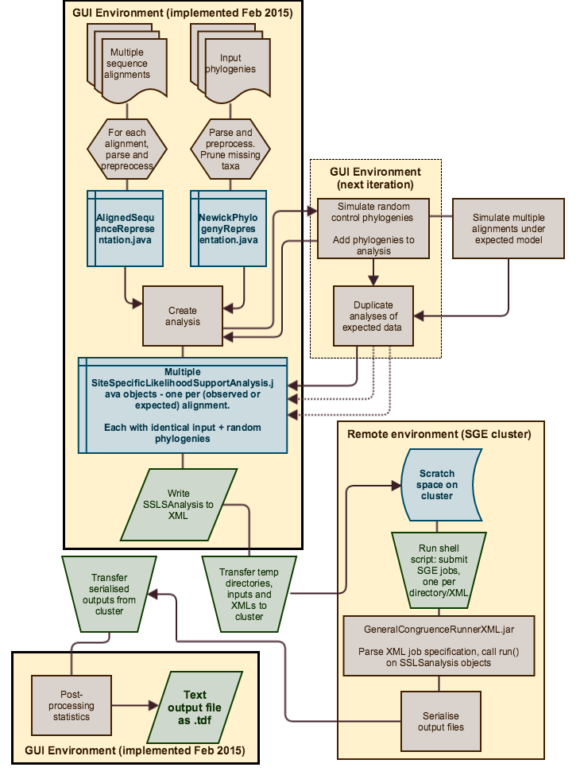

Figure 2: Screenshots showing analysis of example datasets: (a) The alignment input screen, showing 392 multiple sequence alignments together with statistics; (b) The phylogeny input screen, showing input test and null phylogenies with graphical phylogeny display; (c) analyses screen, showing multiple parallel analyses of alignments + phylogenies, configured as XML objects; (d) results screen, showing output summary statistics including convergence ∆SSLS score.
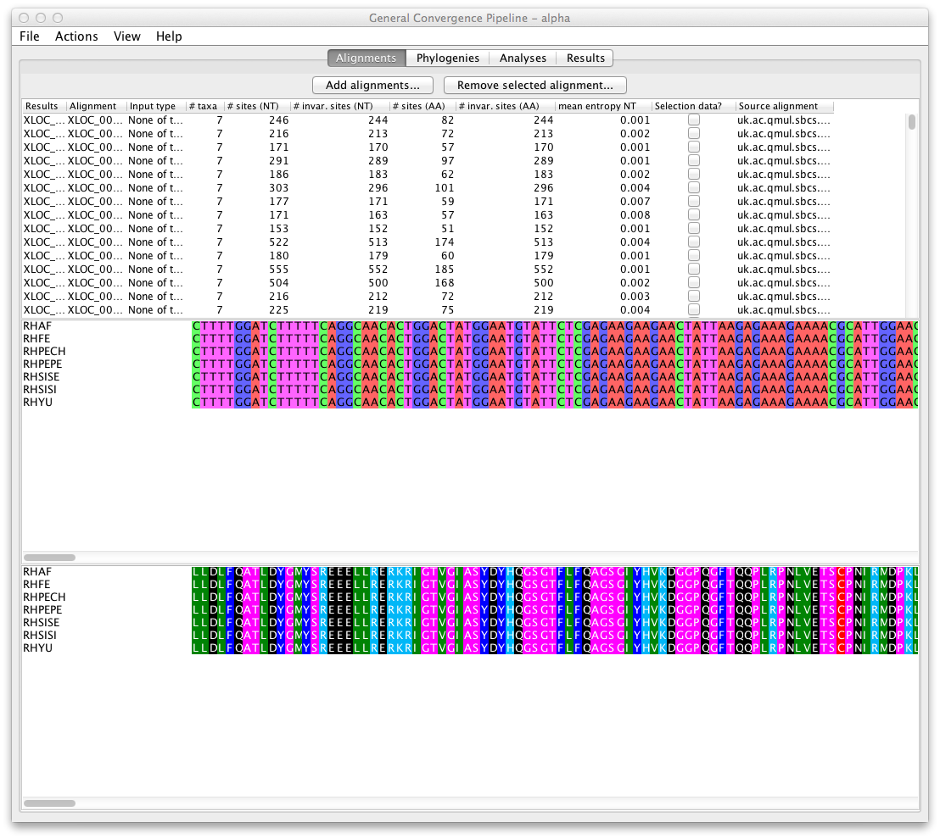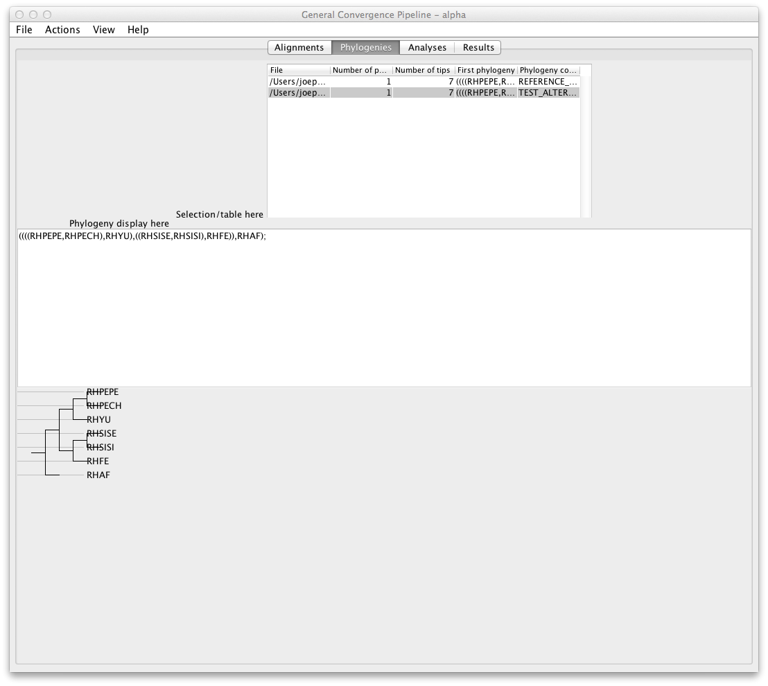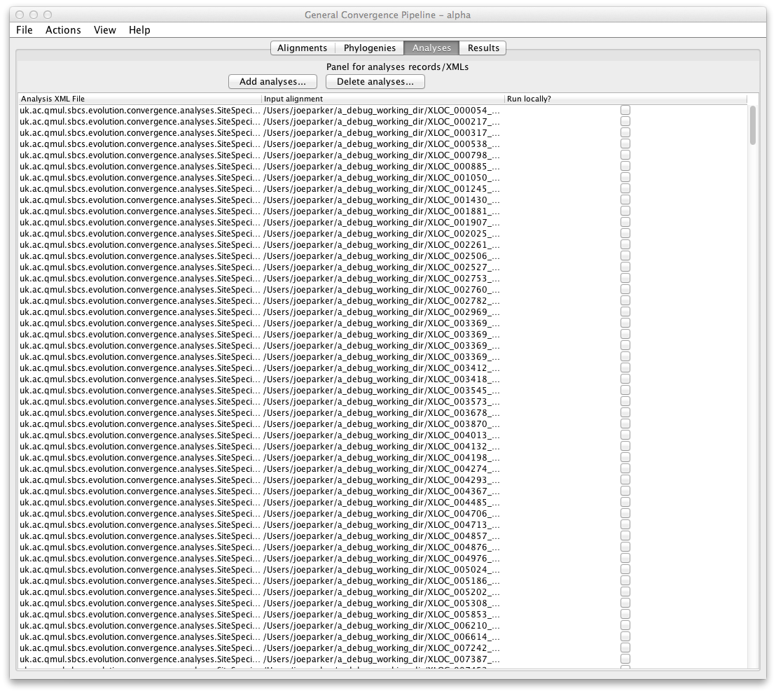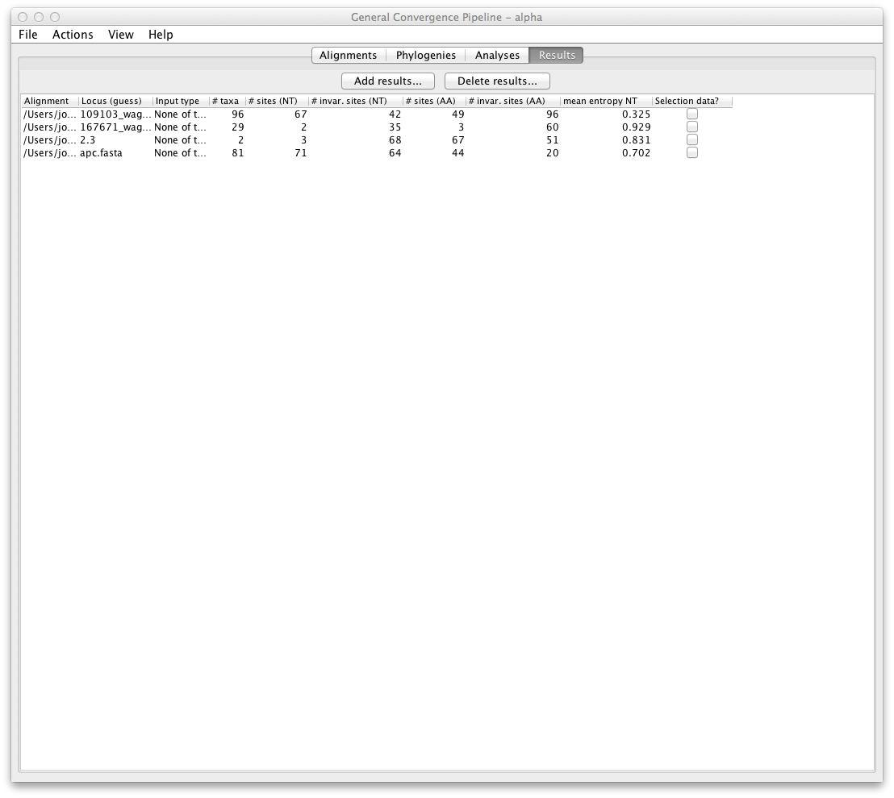

Footnotes

References

